|  |
| --- |
| **Response to Infection -** Practice Examination Questions |

**Multiple-Choice Section (19 marks)**

Suggested working time is 20 minutes

________________________________________________________________________________

1. Which of the following correctly describes the function of mucus in the respiratory tract?

(a) Dissolve microorganisms

(b) Prevent microorganisms entering the stomach

(c) Trap any micro-organisms you breath in

(d) Move microorganisms upwards towards the throat

2. A vaccine created by reducing the virulence of a pathogen is referred to as

(a) an attenuated vaccine.

(b) a toxoid vaccine.

(c) a sub-unit vaccine.

(d) a dead vaccine.

3. Which of the following is not a function of antibodies?

(a) Dissolve pathogen

(b) Make soluble substances insoluble

(c) Produce cytokines

(d) Coat pathogens to stimulate cell removal

4. Lysozyme is an enzyme found in tears. A function of lysozyme is to

(a) break down bacteria on the eye.

(b) trap bacteria on the eye.

(c) flush out bacteria from the eyes.

(d) lubricate surface of the eyes.

1. An individual contracted a malarial parasite after a mosquito took a blood meal from them. Which of the following methods would describe how this disease was transmitted?
   1. By contact.
   2. By a vector.
   3. By body fluids.
   4. By ingestion.
2. Choose the best description of a bacteriophage.
   1. A virus that reproduces within bacteria.
   2. A bacterium that is resilient to viral infections.
   3. Bacteria that are injected with a virus to produce insulin.
   4. Bacterium that have a specific rod shape and flagella.
3. Which of the following is not an example of a non-specific defence?
   1. Sebum which contains substances that kill bacteria.
   2. The beating motion of cilia within the respiratory system.
   3. Cerumen produced by the gastric pits, killing most bacteria that are swallowed.
   4. Urine is slightly acidic and provides a flushing action.
4. Which of the following is true about passive immunity?
   1. The patient’s immune system is stimulated to produce antibodies.
   2. The patient receives the antibodies for a specific pathogen, through an injection.
   3. This type of immunity is prolonged due to the development of memory cells.
   4. Only involves B lymphocytes, while the T lymphocytes are not stimulated.
5. Choose the protective reflex that is correctly matched to its modulator and the nervous system that would stimulate it.
   1. Sneezing; medulla oblongata; somatic division.
   2. Coughing; hypothalamus; autonomic division.
   3. Vomiting; medulla oblongata; autonomic division.
   4. Diarrhea; medulla oblongata; autonomic division.
6. After contact with the chicken pox virus a child developed chicken pox and recovered. Two years later the same child came in contact with the chicken pox virus again but did not show any symptoms of the disease. This happened because, shortly after the first infection, the child:
7. Developed T cells that destroyed the chicken pox virus
8. Had an injection of chicken pox antibodies
9. Developed B memory cells specific to chicken pox
10. Developed antibodies that would destroy any virus including chicken pox
11. An example of active immunity is best illustrated by :
12. Antibody production following exposure to antigens
13. Antibody transfer from an animal into humans
14. Antibodies passing from the mother’s breast milk to baby
15. Antibodies crossing the placenta from mother to foetus
16. Lyme disease is spread by ticks. This is an example of
17. airborne transmission.
18. transmission by vector.
19. transmission by body fluids.
20. transmission by ingestion.

13. Which of the following is true about active immunity?

1. The antibody formed will attack any pathogen.
2. Both B and T lymphocytes can play a role.
3. It is short-lived because no memory cells are involved.
4. Prepared immunoglobulins activate this type of immunity.

14. The enzyme that is found in human tears that helps to kill bacteria is called

1. cerumen.
2. lysozyme.
3. vaccine.
4. leukocyte.

15. Which of the following organs in LIST 1 correctly matches the mode of defence against a possible pathogen in LIST 2?

|  |  |  |
| --- | --- | --- |
|  | LIST 1 | LIST 2 |
| (a) | Trachea | Hairs and mucus |
| (b) | Stomach | Impervious barrier |
| (c) | Skin | Sebum and sweat |
| (d) | Urethra | Digestive enzymes |

16. When B lymphocytes bind to an antigen they undergo cell division to produce a

1. macrophage and a memory cell.
2. memory cell and a killer T cell.
3. plasma cell and a macrophage.
4. plasma cell and a memory cell.

17. Which of the following is NOT an example of a pathogen?

1. Mosquito.
2. Bacteria.
3. Protozoan.
4. Fungi.

18. When an individual experiences a rapid onset of a fever they may feel

1. cold and, as a consequence, vasodilation in the skin and shivering occurs.
2. hot and, as a consequence, vasoconstriction in the skin and sweating occurs.
3. cold and, as a consequence, vasoconstriction in the skin and shivering occurs.
4. hot and, as a consequence, vasodilation in the skin and shivering occurs.

19. Vaccination programs that reduce the chance of disease in individuals and increase the immunity of a population is best described as

1. natural passive immunity.
2. artificial passive immunity.
3. natural active immunity.
4. herd immunity.

**Short Answer Section (45 marks)**

Suggested working time is 45 minutes

_________________________________________________________________________________

**Question 20 (12 marks)**

The body has several lines of defence that prevent pathogens from entering and thus causing disease. As part of the 1st line of defence, external defences and protective reflexes work to stop the majority of pathogens entering the body.

1. Outline four (4) external defenses, describing the role they play in protecting the body from disease. (8 marks)

_________________________________________________________________________________________________________________________________________________________________________________________________________________________________________________________________________________________________________________________________________________________________________________________________________________________________________________________________________________________________________________________________________________________________________________________________________________________________________________________________________________________________________________________________________________________________________________________________________________________________________________________

1. Over the course of an illness such as the flu, a person may develop a fever. Describe what happens to a person’s body when a fever develops. Explain why a fever may be beneficial. (4 marks)

__________________________________________________________________________________________________________________________________________________________________________________________________________________________________________________________________________________________________________________________________________________________________________________________________________________________________________________________________

___________________________________________________________________________

**Question 21 (7 marks)**

A study investigated active and passive immunity to tetanus toxin. One person, **G**, was injected with antibodies to tetanus toxin. Another person, **H**, was injected with a vaccine for tetanus and produced antibodies as a result. Blood samples were taken from both people at regular intervals over the following few weeks and analysed for antibodies against tetanus.

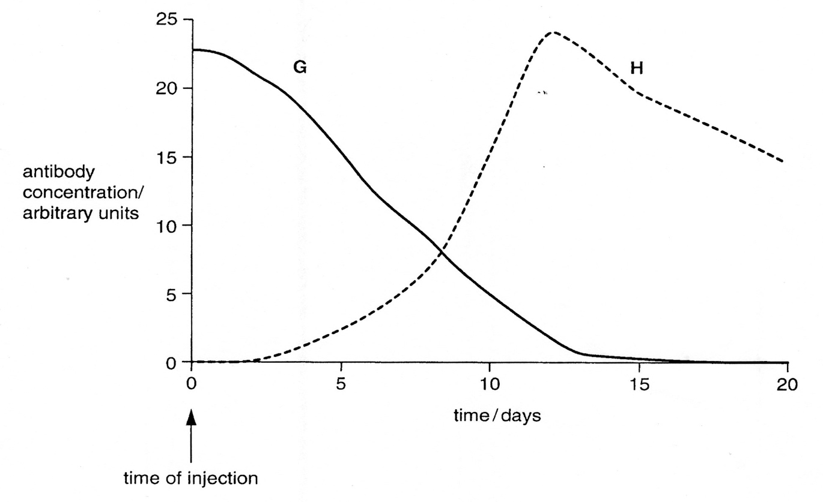The results of the study are shown below.

(a) Explain the type of immunity gained by **G**. (2 marks)

_________________________________________________________________________

__________________________________________________________________________

__________________________________________________________________________

(c) Explain why there is a slow increase in antibody concentration in the curve for **H**. (2 marks)

_________________________________________________________________________

__________________________________________________________________________

__________________________________________________________________________

__________________________________________________________________________

(e)A new mother was concerned about the risk of infection when her 4-month-old baby cut his finger. Her friend told her not to worry, as she was still breastfeeding the baby boy. Explain whether this rationale is correct. (3 marks)

_________________________________________________________________________

__________________________________________________________________________

__________________________________________________________________________

__________________________________________________________________________

__________________________________________________________________________

__________________________________________________________________________

__________________________________________________________________________

**Question 22 (13 marks)**

The graph below shows the immune response of a person to a bacterial infection. Refer to the graph to answer the following questions.

Immune response to bacterial infection.

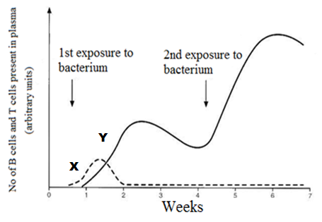

(a) State which of the lines (X or Y) on the graph represent the cloning of the B cells. Explain why you made your choice. (2 marks)

____________________________________________________________________________________________________________________________________________________________________________________________________________________________________________________________________________________________________________

(b) The number of cells represented by the Y line after the second exposure was greater and their production was much faster, despite the person never receiving a vaccination. Explain what allowed this to happen. (2 marks)

________________________________________________________________________________________________________________________________________________________________________________________________________________________________________________________________________________________________________________

(c) After the first exposure to the bacterium, the person experienced an elevation of their body temperature.

(i) State the name of this non-specific response. _____________________ (1 mark)

(iii) Describe two benefits an elevated body temperature is believed to provide as the

body fights against a disease. (2 marks)

________________________________________________________________________________________________________________________________________________________________________________________________________________________________________________________________________________________________________________

(d) There are two types of antibiotics. Name each type and describe how they kill bacteria.

________________________________________________________________________________________________________________________________________________________________________________________________________________________________________________________________________________________________________________________________________________________________________________________________________________________________________________________________________

(4 marks)

(e) The number of doctors that are becoming reluctant to prescribe antibiotics for every patient that presents with an infection is increasing. Describe one reason why doctors would feel this way.

(2 marks)

________________________________________________________________________________________________________________________________________________________________________________________________________________________________________________________________________________________________________________

**Question 23 (7 marks)**

After a race, despite the large volumes of plain water consumed by the athlete, he feels light headed, has a headache and feels nauseous.

As a result of the light headedness, the athlete stumbled forwards and grazed his hands. The palms of his hands are now bleeding, red, swollen, hot and painful.

1. Based on the symptoms listed, name the internal non-specific defensive response that

has been stimulated as a result of the injury.

___________________________________________________________ (1 mark)

(ii) Describe the sequence of events that would keep the wound free of infection and

allow the wound to heal. (6 marks)

________________________________________________________________________________________________________________________________________________________________________________________________________________________________________________________________________________________________________________________________________________________________________________________________________________________________________________________________________________________________________________________________________________________________________________________________________________________________

**Question 24 (6 marks)**

Complete the table below to compare antibody-mediated and cell-mediated immunity

|  |  |  |
| --- | --- | --- |
|  | **Humoral Response**  *Antibody-Mediated Immunity* | **Cellular Response**  *Cell-Mediated Immunity* |
| Antigen type targeted? |  |  |
| Main cells involved? |  |  |
| Where do main cells develop and mature? |  |  |
| Antibodies produced? |  |  |
| How are antigens identified? |  |  |
| How are antigens killed? |  |  |

**Extended Response (20 marks)**

Suggested working time is 20 minutes

_________________________________________________________________________________

*Bacillus cereus* is a bacterium that can cause food poisoning, usually contracted from rice meals which have been allowed to rest at room temperature for hours, particularly at a buffet. If the bacterium is exposed to high temperatures or acidic conditions, they will enter a dormant state and develop a heat and chemical resistant cell wall, until their surrounding environment is favourable again. This dormant and protective state is referred to as being an endospore.

An infection is initially indicated by vomiting and/or diarrhoea and then 30 minutes to 6 hours later the lymph glands/nodes can become swollen. Most patients recover within 6 to 24 hours.

1. Describe how the non-specific defences initially triggered in response to the infection destroy or remove some of the *Bacillus cereus* and explain why they are incapable of completely eradicating the bacteria.

(10 marks)

(b) The swollen lymph nodes are an indication of the specific defences the body employed to destroy the bacterium. State what an antibody is and describe the steps that would occur during a humoral response.

(10 marks)